Class 22CLC – Term II/2023-2024

Course: CSC14003 – Artificial Intelligence

Homework 02
Submission Notices:
- Conduct your homework by filling answers into the placeholders given in this file (in Microsoft Word format). Questions are shown in black color, instructions/hints are shown in italic and blue color, and your content should use any color that is different from those.
- After completing your homework, prepare the file for submission by exporting the Word file (filled with answers) to a PDF file, whose filename follows the following format,
<StudentID-1>_<StudentID-2>_HW02.pdf (Student IDs are sorted in ascending order)
E.g., 2252001_2252002_HW02.pdf
and then submit the file to Moodle directly WITHOUT any kinds of compression (.zip, .rar, .tar, etc.).
- Note that you will get zero credit for any careless mistake, including, but not limited to, the following things.
  - Wrong file/filename format, e.g., not a pdf file, use “-” instead of “_” for separators, etc.
  - Disorder format of problems and answers
  - Conducted not in English.
  - Cheating, i.e., copying other students’ works or let the other student(s) copy your work.

Problem 1. (1pt) Answer the following simple questions by filling in the following blanks.
Please write your answer in the table
Questions (0.25pt each) | Answers
What is local search in constraint satisfaction? | Local search is a technique used in constraint satisfaction problems (CSPs) to find solutions by iteratively exploring the space of possible solutions. Unlike systematic search algorithms, such as backtracking or forward checking, which systematically explore the entire search space, local search algorithms make incremental improvements by iteratively moving from one solution to another.
What is plateau in local search algorithm? | Plateau is the flat area of the search space in which all the neighbor states of the current state contain the same value, because of this algorithm does not find any best direction to move.
What is adversarial search? | Adversarial search is a technique where the objective is to search for the best possible actions in a competitive environment where multiple agents or players are trying to outperform each other. It's commonly applied in game theory and multi-agent systems. In adversarial search, there are typically two or more agents, each with their own set of goals, and the actions of one agent directly affect the outcomes achievable by the others. The primary goal is to find strategies that maximize the agent's own utility while considering the strategies of the opponents.
Which Hill-climbing variation behaves similarly to mutation operator in Genetic Algorithm? | The hill-climbing variation is a basic optimization algorithm used in artificial intelligence for solving computational problems. It belongs to the family of local search algorithms, which iteratively improve a candidate solution by making small incremental changes. The primary idea behind hill-climbing is to continually move towards the best neighboring solution until a peak (or local maximum) is reached. In the context of hill-climbing algorithms, a variation known as "Random Restart Hill Climbing" behaves somewhat similarly to the mutation operator in Genetic Algorithms (GA).
Problem 2. (1pt) For each of the below claims, mark it as True or False, and explain your choice.
Please write your answer in the table
Claims (0.25pt each) | True/False | Explanations
Variations of hill climbing (e.g., Random-restart hill-climbing, local beam search, etc.) are guarantee complete and optimal. | False | They often fail to find an optimal solution when one exists because they can get stuck on the local maxima.
It is possible to get stuck in a local maximum in simulated annealing. | True | Because the algorithm accepts the move with some probability less than 1. The probability decreases exponentially with the “badness” of the move—the amount ΔE by which the evaluation is worsened. The probability also decreases as the “temperature” T goes down: “bad” moves are more likely to be allowed at the start when T is high, and they become more unlikely as T decreases. If the schedule lowers T slowly enough, the algorithm will find a global optimum with probability approaching 1.
There exists some value of $k>0$ such that the heuristic $h(n)=k$ is admissible. | False | Because the heuristic at goal state is not a zero so it cannot be admissible.
A* tree search using the heuristic $h(n)=k$ for some $k>0$ is guaranteed to find the optimal solution. | True | Each state in frontier has priority f(n) = g(n) + h(n) = g(n) + k, and the important thing here is the order of node in frontier so that adding any the constant k makes no change at all. Therefore, we can assume that f(n) ≈ g(n), it is similar using UCS, which will find optimal solution.

Problem 3. (4.5pts) Let's consider a simplified game scenario with a game tree for you to evaluate using Minimax algorithm. This will be a hypothetical two-player game, where Player A is the MAX player, and Player B is the MIN player. Player B accidentally erased all values in the leaf nodes, as illustrated in the tree below.
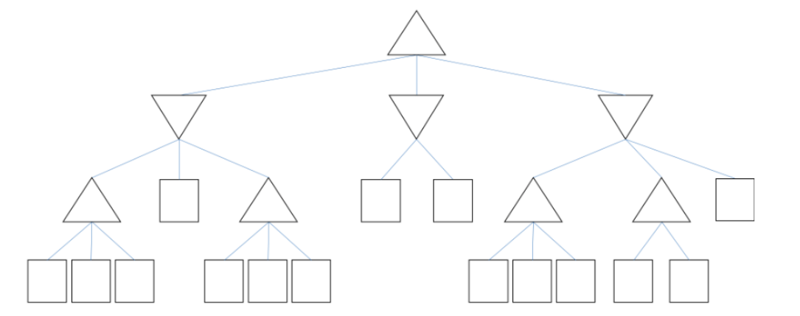
- (1pt) Player A wants to perform alpha-beta pruning on the tree with the same structure.
- What’s the maximum possible number of leaf nodes pruned?
Answer: 6
After identifying the minimum of the maximum value of the left subtree of the root’s left subtree and middle subtree (Temporally call M), if the first leaf of its right subtree is greater than that value, we can prune the remaining two leaf nodes.
It is similar to the middle subtree of the root node; we can prune one leaf node if the first node is smaller than M.
The right subtree of the root does not have any value, we need to find out the maximum value of its left subtree. If it is smaller than the M, then prune 2 its subtree.
- In total, we can have at most 6 leaf nodes pruned.
- What’s the minimum possible number of leaf nodes pruned?
Answer: 0
Because there could always be leaf values making other leaf nodes need being checked.
- (1pt) Since player A answered correctly, player B filled out the leaf nodes again.
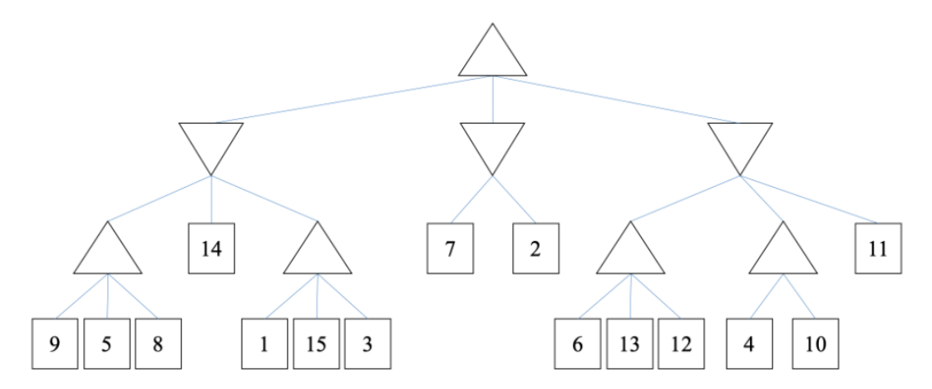
10
10
10
13
15
7
9
9
- How many leaf nodes can be pruned when applying alpha beta pruning?
Answer: 2
- Please identify the pruned branches by putting crosses on them.
- (2.5pts) Player A modifies the leaf node values in the above tree to optimize alpha-beta pruning, aiming to prune the maximum number of leaf nodes. The rearrangement allows for any leaf node value to be shifted to any other position, with the possibility of some values remaining unchanged. This scenario assumes a tree with 15 leaf nodes, each uniquely assigned one of the values from 1 to 15. For all related sub-questions, consider this specific arrangement.
- Hint: Analyze how Player A might organize the leaf values to achieve maximal pruning, encouraging the identification of necessary value constraints for this optimization.
This restructured tree, represented with placeholder letters, serves as the basis for the following inquiries.
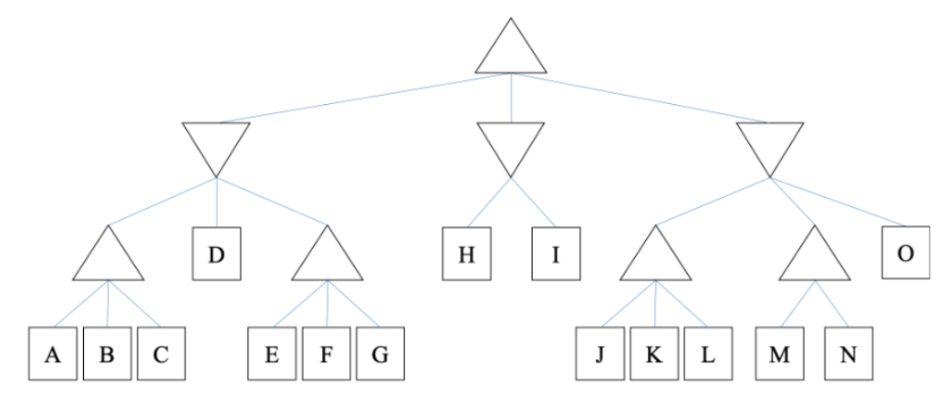
Analyze:
To prune the maximum number of leaf nodes, as explained at question (a):
  - To let F and G pruned, values at node E must be greater than the value that is smaller one between the maximum (A, B, C) or D.
  - To let I pruned, H must be smaller than the value of the root which is the smallest one of the left subtree.
  - To let M, N, O pruned, the maximum (J, K , L) is smaller than root values.
- Among 3 subtrees of the root node, to make H and the maximum (J, K, L) or H, J, K , L are smaller than the value of the left subtree, the smallest value, that the left subtree could have, is 5. The greatest one is 13 because we need to find the minimum of 3 subtrees of the left root node which are 13, 14, 15.
- When the root's value is 8, identify the leaf nodes that must have a value lower than 8.
Answer: H, J , K, L
- Identify the leaf nodes that are certain to have a value of 8 or higher when the root's value is 8.
Answer: D, E
- For a root value of 8, determine which leaf nodes are definitely valued at 8.
Answer: Not sure because it could be one of seven leaf nodes of the left subtree.
- Determine the leaf nodes that must have a value of 6 when the root's value is 6.
Answer: D because if we let maximum of (A, B, C) is equal to 6, we could not identify which of them could have the value of 6 and which value is smaller than 6.
- What root values could result from Player A reconfiguring the game tree?
Answer: From 5 to 13

Problem 4. (3.5pts) Constraint Satisfaction Problems Your teachers in this CSC14003 course have their own secret job at FIT-HCMUS. FIT assigns each teacher to exactly one group. The teachers are Anthony (A), Christiano (C), Lee (L), Roberto (R), Sunny (S), and Zack (Z). You are asked to formulate this situation as a Constraint Satisfaction Problems (CSP) using one variable for each teacher. The groups are as following:
- Group 1: Automation Systems
- Group 2: Mobile Development
- Group 3: Database Construction
- Group 4: System Administration
- Group 5: Internet of Things
- Group 6: Intelligent Robots
Each teacher has their own preferences. Please note that there can be groups having no teacher and groups having more than one teacher.
- Anthony and Christiano must be in the same group.
- Sunny must be in an even group (2, 4 or 6).
- Lee must be in one of the last 3 groups.
- Anthony and Robert must be in different groups.
- Zack must be in the Automation Systems group or Mobile Development group.
- Christiano’s group number must be greater than Lee’s group number.
- Lisa cannot be in a group with any other teachers.
- (1pt) Please construct the constraint graph for this problem by adding edges to the following graph (also note that doing this only involves the binary constraints).

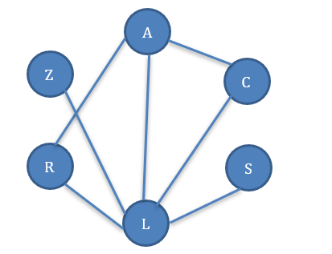
Answer: Anthony and Christiano must be in the same group. This constraint creates a binary constraint between Anthony (A) and Christiano (C), meaning they must share the same group. So, we add an edge between A and C. Lisa cannot be in a group with any other teachers, so there is a bond between Lisa (L) and the other teachers. Anthony and Robert must be in different groups. This constraint creates a binary constraint between Anthony (A) and Robert (R), meaning they cannot share the same group. So, we add an edge between A and R.

- (1pt) Adding a middle cross (e.g., 3) to the group numbers that are removed from the domains after enforcing all unary constraints. Please justify your answer.
A: 1 2 3 4 5 6
C: 1 2 3 4 5 6
S: 1̶ 2 3̶ 4 5̶ 6
L: 1̶ 2̶ 3̶ 4 5 6
R: 1 2 3 4 5 6
Z: 1 2 3̶ 4̶ 5̶ 6̶

Answer: All variables {A, C, S, L, R, Z} have the domain {1, 2, 3, 4, 5, 6} representing the six
groups.
Constraints:
Anthony and Christiano must be in the same group. Constraint: A = C
Sunny must be in an even group (2, 4, or 6). Constraint: S ∈ {2, 4, 6}
Lee must be in one of the last 3 groups. Constraint: L ∈ {4, 5, 6}
Anthony and Roberto must be in different groups. Constraint: A ≠ R
Zack must be in the Automation Systems group (Group 1) or Mobile Development group (Group
2). Constraint: Z ∈{1, 2}
Christiano’s group number must be greater than Lee’s group number. Constraint: C > L

A (Anthony's group): No specific unary constraint.
C (Christiano's group): No specific unary constraint.
S (Sunny's group): Restricted to even numbers only, so it becomes {2, 4, 6}.
L (Lee's group): Restricted to the last three groups, so it becomes {4, 5, 6}.
R (Roberto's group): No specific unary constraint.
Z (Zack's group): Restricted to Group 1 or Group 2, so it becomes {1, 2}.

A: 1 2 3 4 5 6
C: 1 2 3 4 5 6
S: 1̶ 2 3̶ 4 5̶ 6
L: 1̶ 2̶ 3̶ 4 5 6
R: 1 2 3 4 5 6
Z: 1 2 3̶ 4̶ 5̶ 6̶
A: 1 2 3 4 5 6
C: 1 2 3 4 5 6
S: 1 2 3 4 5 6
L: 1 2 3 4 5 6
R: 1 2 3 4 5 6
Z: 1 2 3 4 5 6

- (0.5pt) Consider the filtered domains obtained in part (b). Which teacher should be selected according to Minimum Remaining Values (MRV)? Give a short explanation.
Answer: According to part b, their domains are:
A (Anthony): {1, 2, 3, 4, 5, 6}
C (Christiano): {1, 2, 3, 4, 5, 6}
S (Sunny): {2, 4, 6}
L (Lee): {4, 5, 6}
R (Roberto): {1, 2, 3, 4, 5, 6}
Z (Zack): {1, 2}

The teacher with the smallest remaining domain is Zack (Z), with only two possible groups: {1, 2}. Therefore, according to the Minimum Remaining Values (MRV) heuristic, Zack should be selected next. This choice increases the likelihood of satisfying the constraints as it reduces the branching factor and explores the search space more efficiently.

- (1pt) Given the following set of filtered domains. Adding a middle cross (e.g., 3) to the group numbers that are eliminated by enforcing arc consistency at this stage. You should enforce binary constraints only. Please justify your answer.

A: 1 2 3 4 5 6
C: 1 4
S: 4
L: 2 3 4 5 6
R: 1 4 5 6
Z: 1 2 3 4 5 6

Explanation:
- Christiano’s (C) group number must be greater than Lee’s (L) group number: No direct elimination at this stage.
- L ∈ {2, 3}, C ∈ {4}
- Anthony (A) and Christiano (C) must be in the same group: Eliminates group 1, 2, 3, 5 and group 6 for A.
- A ∈ {4}

- Anthony (A) and Roberto (R) must be in different groups: Anthony (A) in group 4, so eliminates group 4 for Roberto (R).
- Z ∈ {1, 5, 6}

- Lee cannot be in a group with any other teachers. Lee (L) and Zack (Z) have two identical domains, so there are 4 cases: L accepts group 2, then Z eliminates group 2. Or L accepts group 3, then Z eliminates group 3. L accepts group 2 and 3, then Z eliminates group 2 and 3. L doesn’t accept any groups, then Z accepts group 2 and 3.
L ∈ {2}, Z ∈ {1, 3, 4, 5, 6}
L ∈ {3}, Z ∈ {1, 2, 4, 5, 6}

L ∈ ∅, Z ∈ {1, 2, 3 4, 5, 6}
L ∈ {2, 3}, Z ∈ {1, 4, 5, 6}

Case 1:
A: 1̶ 2̶ 3̶ 4 5̶ 6̶
C: 1̶ 4
S: 4
L: 2 3̶ 4̶ 5̶ 6̶
R: 1 4̶ 5 6
Z: 1 2̶ 3 4 5 6

A: 1 2 3 4 5 6
C: 1 4
S: 4
L: 2 3 4 5 6
R: 1 4 5 6
Z: 1 2 3 4 5 6

Case 2:
A: 1̶ 2̶ 3̶ 4 5̶ 6̶
C: 1̶ 4
S: 4
L: 2̶ 3 4̶ 5̶ 6̶
R: 1 4̶ 5 6
Z: 1 2 3̶ 4 5 6

A: 1 2 3 4 5 6
C: 1 4
S: 4
L: 2 3 4 5 6
R: 1 4 5 6
Z: 1 2 3 4 5 6
Case 3:
A: 1̶ 2̶ 3̶ 4 5̶ 6̶
C: 1̶ 4
S: 4
L: 2̶ 3̶ 4̶ 5̶ 6̶
R: 1 4̶ 5 6
Z: 1 2 3 4 5 6

A: 1 2 3 4 5 6
C: 1 4
S: 4
L: 2 3 4 5 6
R: 1 4 5 6
Z: 1 2 3 4 5 6
Case 4:
A: 1̶ 2̶ 3̶ 4 5̶ 6̶
C: 1̶ 4
S: 4
L: 2 3 4̶ 5̶ 6̶
R: 1 4̶ 5 6
Z: 1 2̶ 3̶ 4 5 6

A: 1 2 3 4 5 6
C: 1 4
S: 4
L: 2 3 4 5 6
R: 1 4 5 6
Z: 1 2 3 4 5 6

